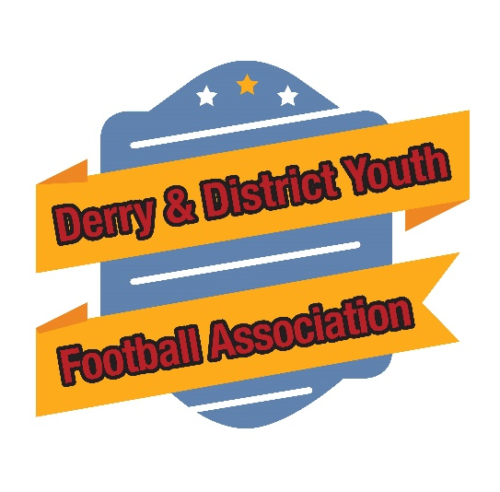

Derry & District Youth Football Association
Constitution

Season 2025/26

www.derrydistrictyfa.co.uk

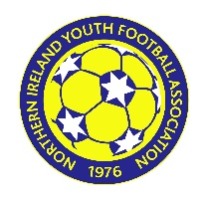
  AFFILIATED TO
  NORTHERN IRELAND YOUTH FOOTBALL ASSOCIATION
  www.niyfa.co.uk
League email address
League Contact Number
League Postal Address
Postcode
Chairperson
Secretary
Treasurer
Fixtures Secretary
League Entry Fees – Season 2026
New Club Bond (if applicable) Season 2026
Disciplinary Fines in Season |  | Must be paid via IFA Comet System

CONSTITUTION
- NAME - This Association of clubs shall be called Derry & District Youth Football Association (hereinafter called The League) and The League and its members shall be affiliated to the Northern Ireland Youth Football Association (NIYFA) which will confer Associate Membership of the Irish Football Association.
- OBJECT – The object of The League shall be to legislate for, foster, develop, and provide a fit for purpose governance structure to service and improve the game of association football among all classes of Youth Football Clubs.
- LEAGUE COMMITTEE – The management of The League shall be vested in a Committee, consisting of the following office bearers, a Chairperson, a Deputy Chair, a Secretary, a Treasurer and elected and/or co-opted representatives from Clubs in the League (except where a Club is represented by an office bearer) plus additional membership duly elected or co-opted up to a maximum of nine (9) persons including office bearers. The League must appoint a Designated Children’s Safeguarding Officer in accordance with Irish FA Safeguarding Policy and Procedures.
The committee members and office bearers shall be elected once every two years. All retiring office bearers shall be eligible for re-election. 50% of members plus 1 of the Committee shall form a quorum. In the event of a vacancy occurring during the season or should a committee member miss 4 consecutive meetings they will be required to stand down and the League Committee shall have the power to fill such vacancy. No Club shall have more than one member on the League Committee.

4. MEMBERSHIP –
- Teams will be invited into membership of a league upon consideration of their application and available places. All such teams are expected to meet the terms of membership set out below.
- All teams must affiliate to the Northern Ireland Youth Football Association.
- All Teams must insure their members through the approved Northern Ireland Youth Football Association scheme.
- All Clubs in membership must be controlled and managed by a committee approved by the Northern Ireland Youth Football Association. This committee must be not less than three (3) in numbers and should encourage a development strategy so that at least one member of each participating team shall be in possession of a current Irish Football Association Coaching Certificate. The relevant minimum certificate recommended being as follows:
For Clubs up to and including Under 12 level - IFA National Coaching Certificate or
equivalent
For Clubs up to and including Under 17 level - UEFA C Diploma
For Clubs at Under 18 level - UEFA B Diploma

- It shall be mandatory for at least one coach from each participating team to hold a current First Aid Certificate or Sports Injuries Certificate. These conditions as to certification/coaching qualifications should be achieved within one year of the Club’s initial acceptance into membership of the league.
It is also strongly recommended that all coaches undertake basic mental health training. The training/information will increase their awareness of the subject and enable them to signpost support if ever required to their club members. Click on the links below.
http://www.sportni.net/mental-health-training-courses/
https://www.zerosuicidealliance.com/training
- Club official shall mean any person aged 16 years or over who, whether registered with a member Club or not, acts on behalf of a member Club by being in the dressing room, entering the field of play on behalf of a member Club, in the absence of an official referee acts as a match referee or as a referee’s assistant on behalf of a member Club, being in a member club’s technical area or assisting in the running of the member Club. A Club official may only be a member of one Club unless additional memberships are approved by the Irish Football Association and verified to the League.
Clubs shall ensure their officials are registered (see also Rule 5(d) for coaching staff) and are subject to the satisfactory outcome of checks by Access (NI) and adherence to the terms of the NIYFA /Irish FA Safeguarding Children and Young People Policy & Procedures. The League must take all reasonable steps to ensure clubs compliance with Irish FA Safeguarding Policy and Procedures and make relevant information available to the Irish FA for auditing purposes.

Managers, Coaching or Administrative staff who move to a new club at any time must have their Access (NI) checks updated before they are eligible to take up a relevant position within the new club. All changes of Club officials, Designated Children’s Safeguarding Officers or Disciplinary Officers shall be notified to the League and NIYFA in writing or email within two working days of such change.
See Appendices 1 and 2 for Irish FA Safeguarding Policy and vetting checks procedures. Failure to comply with these conditions may see an official and or club having their membership revoked.
- Any Club wishing to alter its name must first obtain the prior written consent of NIYFA.
- Clubs who do not comply with the above criteria will not be eligible for membership. Clubs in membership who fail to comply with the criteria during the term of its membership will be reported to the NIYFA and may have their membership suspended until they fulfil their obligations.
- Clubs who accept an offer of a place for any team in the league in any season who subsequently withdraw or fail to complete a season in the league, at the discretion of The League may not be permitted to reapply for a place for that team for a minimum of two seasons.
5. (A) ANNUAL GENERAL MEETING - An Annual General Meeting of the League shall be held each year, except in exceptional circumstances where the committee need an extension to the date to complete work that is relevant to the overall administration of the league. Clubs and teams in default of their financial obligations to the league of more than 30 days will not be entitled to a vote. Any subsequent amendments that are relevant to youth football adopted by IFA/NIYFA must be incorporated into the League Constitution, Rules and or Disciplinary Code as appropriate.

(B) EXTRAORDINARY GENERAL MEETING –
- An Extraordinary General Meeting (EGM) may be called by the members in accordance with clause (5B-2).
- The League shall convene an EGM upon a receipt of a requisition, signed by a registered official of at least 25% of all Clubs in membership, within 28 days of receipt of such a requisition.
- The requisition shall state the business to be considered and shall be accompanied by a deposit in the sum of £500.
- The member clubs signing the requisition may forfeit their deposit and or may be liable for the reasonable expenses of the EGM should the requisition be deemed frivolous.
- The League may call an EGM by a simple majority vote of the league committee and shall convene an EGM within 28 days of such a vote.
- GENERAL MEETINGS – Meetings of The League Committee shall be held at a venue and date notified by The League Secretary. The League will hold a minimum of four general meetings of member Clubs including the Annual General Meeting in each season. Each club shall be entitled to send a representative to all General Meetings, club representatives in attendance will have one vote. All motions shall be carried by a simple majority vote of those present at the meeting and entitled to vote. Clubs and teams in default of their financial obligations to the league of more than 30 days will not be entitled to a vote.
All Clubs must send a representative to notified league meetings, failure to do so will result in a fine of £25 for non-appearance at any notified meeting. Failure to attend on more than two occasions may result in a Club being suspended. All league officials as a matter of good practice may be subject to the satisfactory outcome of Criminal Record Checks by Access (NI) and adherence to the terms of the NIYFA/Irish FA Safeguarding Children and Young People Policy & Procedures – See Appendices 1 and 2.
- LIFE MEMBERSHIP – Past Chairpersons, on retiring from office shall be granted life membership of The League. In addition, the office bearers may recommend at the AGM that life membership be granted to any person whom it is considered has rendered valuable service to The League or in the cause of youth football. Persons granted membership in such fashion will not be eligible to sit on committees.
- DELEGATES TO THE NIYFA – The membership are entitled to send delegates, one per
affiliated team in membership of the NIYFA to the Northern Ireland Youth Football Association Annual General Meeting or Extraordinary Meeting.

- CHAIR – The appointed Chairperson of The League shall preside over all meetings; in the event of his/her absence the chair shall be taken by either the Vice Chairperson or an agreed office bearer of The League. The Chair shall have both a deliberative and casting vote at all meetings, and his/her rule shall be final.
- DECLARATION OF INTEREST - Any member of the Committee who has a vested interest in any discussion or decision under consideration MUST declare such interest. A member with such interest shall be required to retire from the meeting during the discussion or consideration or while a decision is being taken in respect of any case involving his/her Club or Officials or players connected with his/her Club.
- FINANCE – The Treasurer shall be responsible for all money transactions and at the Annual General Meeting submit a detailed statement of accounts. The Audited accounts of the league will be available for inspection upon completion. The Bank account will be in the name of the LEAGUE, the signatories being a minimum of three nominated officials. Two signatures are required for all financial transactions.
- DISSOLUTION – If upon the winding up or dissolution of The League there remains after the satisfaction of all its debts and liabilities any property or assets whatsoever, the same shall not be paid or distributed among the members of The League but shall be: -
(i) applied directly to and for the objects of NIYFA by expending the whole or part of such property or assets in whole or in part in furthering the objects of NIYFA, or
(ii) by transferring the same in whole or in part to another body having objects like the objects of NIYFA as determined by the membership of the league at a general meeting.
- ALTERATION OF CONSTITUTION AND RULES – No alteration shall be made to the
Constitution or Rules of The League except at the Annual General Meeting or Extraordinary General Meeting called for that purpose. On a date to be notified annually, notice must be given to the League Secretary (in writing) of any proposed alteration/s to the Constitution or Rules, a copy of which shall be made available to Clubs seven days before the Annual or Extraordinary Meetings for the consideration thereof.

No alteration shall be made to the Constitution or Rules unless carried by a simple majority of those present at the meeting and entitled to vote.
Any proposed alteration of the Constitution or Rules shall, before coming into force, be subject to compliance with the Constitution of the Northern Ireland Youth Football Association and if ratified be included in the overarching generic league rules as defined by NIYFA.
- INTERPRETATION - The League committee or NIYFA (if the matter has been referred to NIYFA) shall be the final authority on the interpretation of the Constitution and Rules. Decisions by The League or NIYFA on questions of interpretation and on matters affecting The League not provided for by the Constitution or Rules shall be final and binding on all members.

