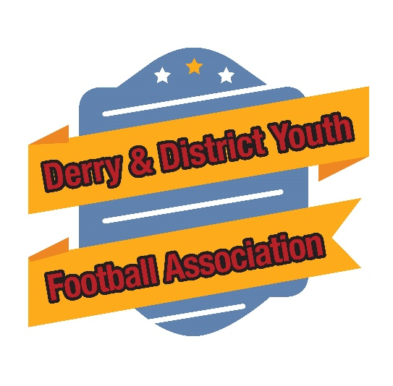

Derry & District Youth Football Association
Safeguarding Children & Young People
& Vetting Checks

Season 2026

www.derrydistrictyfa.co.uk

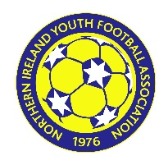
  AFFILIATED TO
  NORTHERN IRELAND YOUTH FOOTBALL ASSOCIATION
  www.niyfa.co.uk

PLEASE NOTE THE SHORT AND FULL VERSIONS OF THE IFA SAFEGUARDING POLICIES ARE AVAILABLE TO DOWNLOAD FROM YOUR LEAGUE WEBSITE.
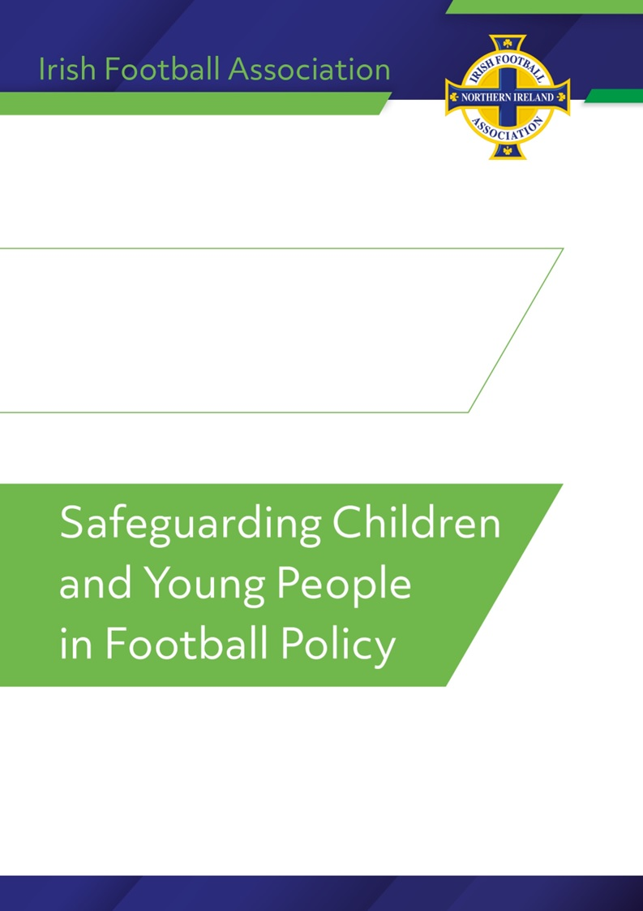
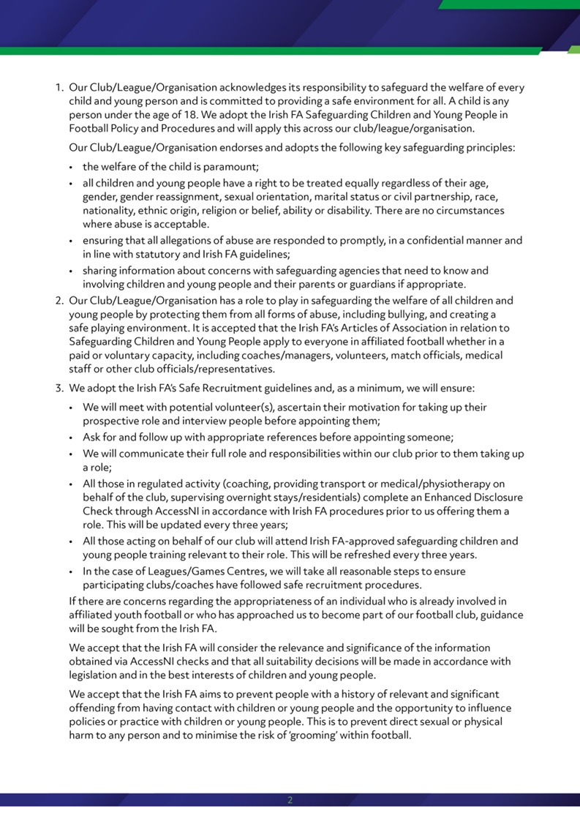
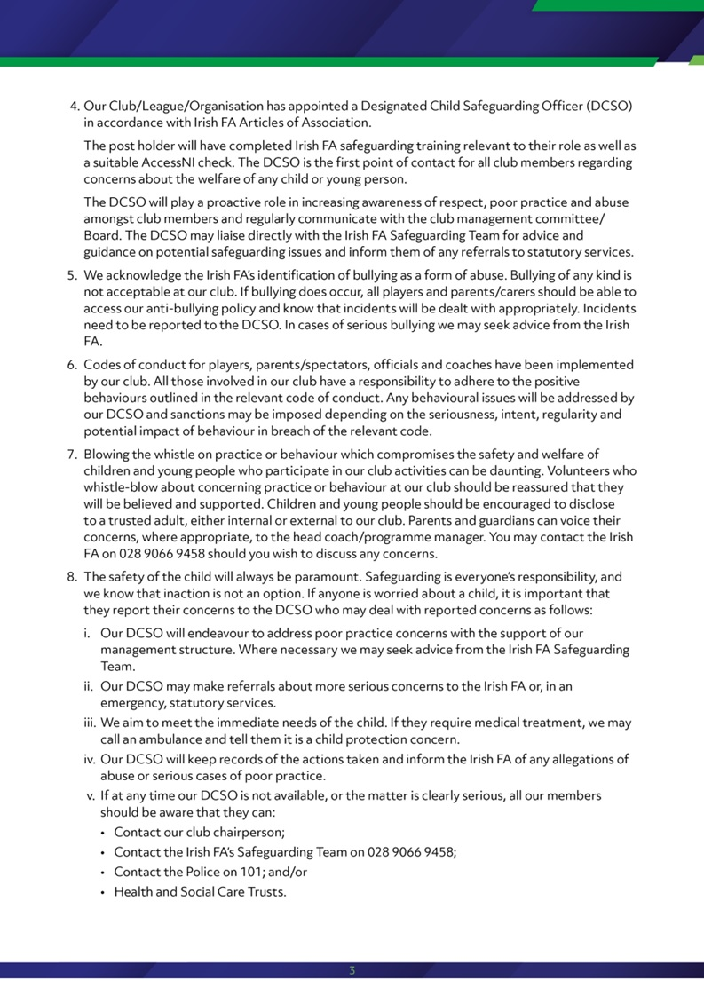
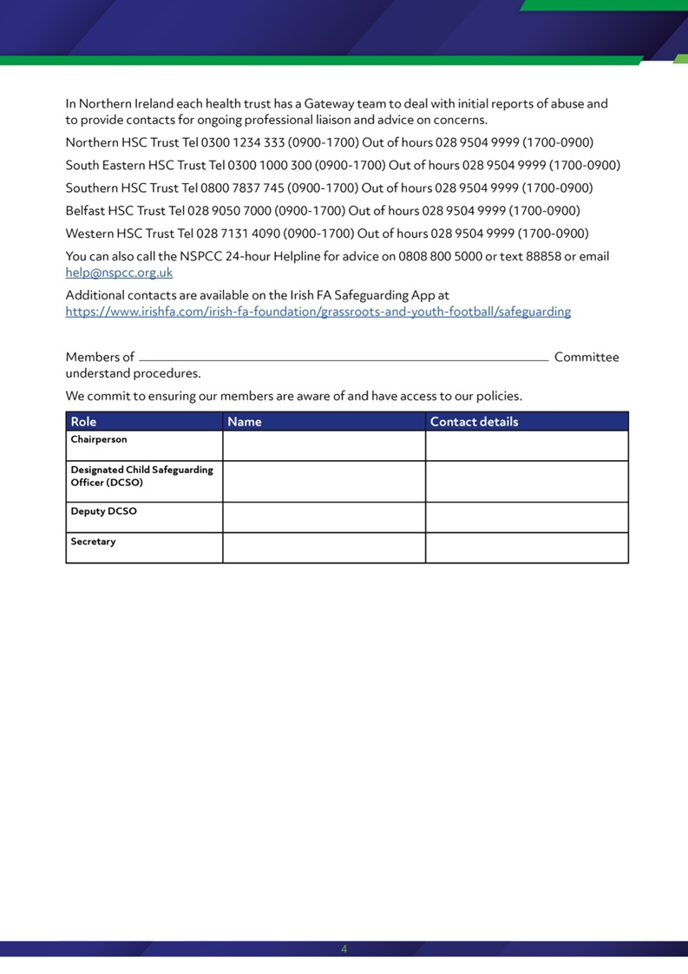
APPENDIX 3 - VETTING CHECKS
To register an official, all clubs, leagues, affiliated bodies and Associations must follow appropriate selection procedures ensuring they are satisfied with the applicant/volunteer. This process should include but is not limited to:
An application process.
- Confirmation of any experience working with children.
- Previous coaching experience.
- A commitment to engage in additional training as required by the club.
- Reference checking.
If satisfied with the applicant/volunteer, the club, league or association/affiliated body must ensure that all volunteers engaging in Regulated Activity complete an Enhanced Disclosure Vetting Check prior to confirmation of their membership.
To allow the Irish FA/NIYFA to assess the suitability of a club official to take up membership of the NIYFA, the club, league/association or affiliated body must ensure that the club official engaging in Regulated Activity completes a satisfactory vetting check.
The application process is as follows:
- When satisfied with the applicant, the club will issue a hard copy of the AccessNI application form to each applicant. This application can be found at https://www.irishfa.com/irish-fa-foundation/grassroots-and-youth-football/safeguarding
- Each applicant must complete the application full, including the online registration for an Enhanced Disclosure Check (against the Barred list if the work is unsupervised).
- Each applicant must return the application form to the club welfare officer or chairperson along with 3 pieces of identification for identity checking.
- Each applicant should, if necessary, submit the self-declaration form outlining any relevant cautions and/or convictions to Kevin Doyle, Irish FA Safeguarding Manager, NFS Windsor Park, Belfast, BT12 6LU.
- The club welfare officer/chairperson should record the name, dob and AccessNI reference number and forward the application form and copies of identification to Kevin Doyle, Irish FA Safeguarding Manager, NFS Windsor Park, Belfast, BT12 6LU. All information should be included on the relevant online club registration system.
- On receipt of the completed application the Irish FA will:
- Process the application to AccessNI.
- Receive notification from AccessNI outlining:

- Nothing to disclose – The Irish FA/NIYFA will inform the club welfare officer/chairperson that the individual could be considered for appointment.
- Certificate Issued – The Irish FA will request from the applicant, the original disclosure certificate and a full explanation of any disclosures outlined within. The applicant may provide or be required to provide relevant additional information allowing the Irish FA to assess the individual’s suitability to fulfil their proposed role. This may include but is not limited to written references and/or additional reports relating to the convictions. The applicant may be required to attend an interview as part of the assessment process. The Irish FA will inform the club, league or affiliated body if the applicant has been successful and any measures that should be put in place to manage any identified risk. The club/league/affiliated body may be required to engage in this assessment process.
- Further information required – the Irish FA may be required to request additional information from the applicant for the purposes of progressing the application.
This decision will be taken by the Irish FA Case Management Panel.
The Irish FA is committed to equal opportunities for all and does not preclude applicants with criminal convictions. Convictions will only be considered when relevant to the position that the applicant has applied for.
Applicants whose disclosure certificate returns information in relation to their criminal record will be judged on a case-by-case basis. Disclosures do not necessarily preclude a person from taking a role within affiliated youth football.
The assessment of suitability will depend on several factors:
- the nature of the position.
- the self-disclosure of any prosecutions or convictions.
- the seriousness, timing and any possible pattern that emerges of any information disclosed.
- the potential of reoffending to cause harm to young people/vulnerable adults.
The following information is considered:
- Age of applicant now and at the time of the offence.
- Type and nature of the offence.
- Number of offences on record.
- Pattern of offending or date since last offence.
- Contact with young people and/vulnerable adults.
- Any mitigating factors.
- Any aggravating factors.
- Disclosure by applicant.
- Cooperation with case management process.
Disclosure of certain types of convictions/prosecutions may automatically preclude the applicant from a position working with children. Examples of offences that may prohibit an applicant are:
- Any offence of a sexual nature.
- Any offence against a child.
- An offence that causes gross bodily harm.
- An offence of kidnapping.
- A series of continuous offending that might cause concern for the well-being of children.

Any applicant who submits inaccurate information (at any stage of the process), omits relevant information, or does not engage meaningfully in the assessment process may not be permitted to take up membership of the NIYFA either temporarily or permanently.
All documentation will be returned to the applicant on completion of the process. The Irish FA will retain confirmation of the decision to grant membership or not.
All clubs, leagues, affiliated and associated bodies must ensure they maintain accurate and up to date record of all club officials including confirmation of vetting checks and safeguarding training, both of which should be updated every 3 years.
Appeals
An appeals process can be made available to any individual who is subject to a decision made by the CMP.
- All requests must be submitted in writing, by special-delivery post, within 14 days after the date the decision was intimated in writing to the individual concerned.
- A fee of £75 must be enclosed with the appeal. The fee shall be returned only where the appeal is upheld or not heard.
- The request must clearly identify the decision the individual wishes to appeal, on what grounds they wish to make the appeal, and reasons as to why it would be unfair not to change the decision. Evidence must also be submitted to support the claim.
- The Appeals Panel will exclude any person who sat on the original CMP.
- Where an appeal has been rejected or not heard, the initial decision made by the CMP will stand.
- The Appeals Panel will notify the individual, in writing, of the outcome of the appeal process.
Should an individual wish to withdraw their appeal prior to the hearing taking place, they must notify the Irish FA's Safeguarding Team in writing. In such cases, the original decision made by the CMP will be upheld. The individual may also be subject to a cancellation fee.

